Three days European course in Athens, Greece
Preparation of proposals and management of european projects under ERASMUS+

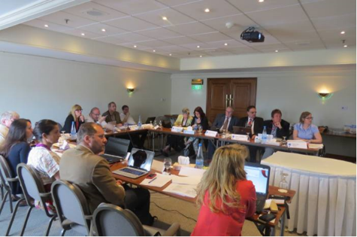 | The European Office of Cyprus in cooperation with the European Association of Erasmus Coordinators organize a 3-days international course with title “Preparation of Proposals and Management of European Projects under ERASMUS+”  13, 14 και 15 February 2015,Athens, Greece  Venue:  HOUSE OF CYPRUS  Cultural and Educational Office of the Embassy of the Republic of Cyprus in Greece  2A, Xenofontos Str.  105 57, Syntagma Square, Athens  Greece

CONTENT OF THE COURSE  · Introduction to ERASMUS+ Programme  · Objectives / Priorities  · Structure of a proposal  · Eligible and non-eligible activities and expenses  · Tools for background preparation  o Work distribution to partners  o Staff cost estimation  o Operations Expenses Estimation  · Outputs and related activities  · Networking and partner search  · Budget  · Review of approved proposals  · Management of the project after approval  · Practical work | COURSE FEES  Α. Without accommodation: €325 per person (includes 3 meals, coffee breaks, course material, Europass certificate)  B. With 2 nights’ accommodation: €475 per person (includes 2 nights’ accommodation in single room, 5 meals, coffee breaks, course material, Europass certificate)  Γ. With 3 nights’ accommodation: €550 per person (includes 3 nights’ accommodation in single room, 6 meals, coffee breaks, course material, Europass certificate)  20% discount for EOC Members in the basic charge A.

TRAINER  -->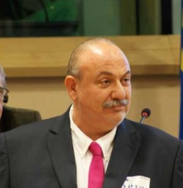 | -->  Dr Gregory Makrides  “2014 Award for outstanding achievements in development of the EU through European Projects”  Executive Director, European Office of Cyprus  Director of Research and International Relations, University of Cyprus  President of the European Association of Erasmus Coordinators

-->The seminar will be offered in English Language | -->Maximum number of places: 25
MORE INFORMATION AND REGISTRATION
Please send us an email to eoc@ucy.ac.cy, indicating the name of your organization and the name of the person(s) who will attend the seminar. Contact Phone: +357 22 89 4278
-->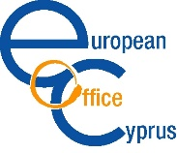 | -->European Office of Cyprus  1 Panepistimiou Avenue  2109 Aglantzia, Nicosia, Cyprus  www.eoc.org.cy, eoc@ucy.ac.cy |  | European Association of ERASMUS Coordinators  1 Panepistimiou Avenue  2109 Aglantzia, Nicosia, Cyprus  www.eaecnet.com, info@eaec.eu.com

